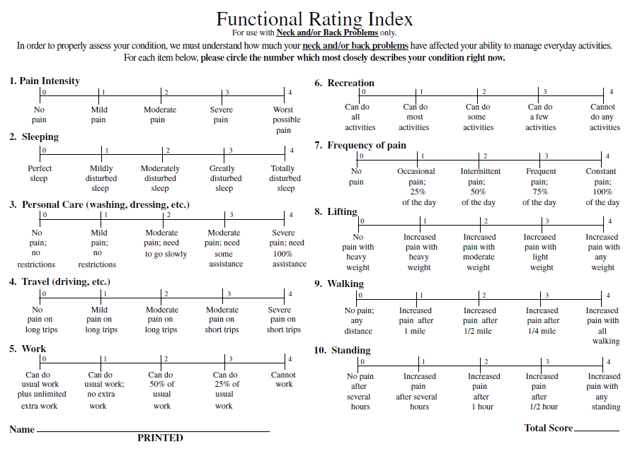

Add Total Score:_______ /40 = ______ % Disability.